**SECTION A (60 Marks)**

Answer only **three** questions from this section.

1. (i) Define the term **colligative property**. (01 mark)

(ii)State the **colligative properties** of a solution. (02 marks)

1. (i) Describe how molecular mass of cane sugar can be determine using one of the colligative properties. (06 marks)

(ii)State limitations of the method used. (02 marks)

1. The table below shows the freezing points of various solutions of cane sugar in solvent **X**.

|  |  |  |  |  |  |  |  |
| --- | --- | --- | --- | --- | --- | --- | --- |
| Mass of cane sugar  (g /1000g of solvent **X**) | 26 | 42 | 66 | 78 | 118 | 148 | 173 |
| Freezing point. (oC) | 5.11 | 4.87 | 4.51 | 4.33 | 3.73 | 3.28 | 2.91 |

1. Plot a graph of freezing against mass of cane sugar and use graph to determine the: (03 marks)
2. Freezing point of solvent **X.** (01 mark)
3. Freezing point constant for solvent **X**. (02 marks)

[RMM of cane sugar = 342]

1. State and explain how the freezing points of the solution would be affected if cane sugar associates in solution **X**. (03 marks)
2. Define the terms: (@01 mark)
3. Conductivity.
4. Molar conductivity.
5. The table below shows the molar conductivities of an aqueous solution of sodium hydroxide.

|  |  |  |  |  |  |  |
| --- | --- | --- | --- | --- | --- | --- |
| Concentration (moldm-3) | 0.01 | 0.04 | 0.09 | 0.16 | 0.25 | 0.36 |
| Molar conductivity Λ/ Scm2mol-1 | 238 | 230 | 224 | 217 | 210 | 202 |

1. Plot a graph of molar conductivity against square root of concentration. (03½ marks)
2. Use the graph to determine the molar conductivity of sodium hydroxide at infinity dilution. (01 mark)
3. Explain the shape of the graph. (03 marks)
4. Draw a sketch graph to show the change in the conductivity with volume of ammonia solution when 25cm3 of 0.1M methanoic acid is titrated with 0.1M ammonia solution. (02 marks)
5. Explain the shape of the graph. (03½ marks)
6. The conductivity of a saturated solution of silver phosphate at 25oC is 2.661x 10-6Scm-1 and that of pure water is 1.519 x 10-6Scm-1. If the molar ionic conductivities of silver ions and phosphate ions at infinite dilution at 25oC are 61.9 and 240Scm2mol-1 respectively. Calculate the:
7. Solubility of silver phosphate in molesdm-3 at 25oC. (02½ marks)
8. Solubility product of silver phosphate at 25oC and state its units. (02½ marks)
9. Write the formulae of the chlorides of group (IV) elements. (03½ marks)
10. State the condition (s) and write equation for the reaction to show the preparation of:
11. Chloride of carbon. (02½ marks)
12. Chloride of silicon (02½ marks)
13. Chlorides of lead (05 marks)
14. Describe the reactions of chlorides of group elements with water. (06½ marks)
15. Complete the following equations and in each case outline a mechanism for the reaction.



**SECTION B (40 Marks)**

Answer only **two** questions from this section

1. State:
2. Partition law. (01 mark)
3. **Three** limitations of the law. (01½ marks)
4. Describe an experiment to determine the partition coefficient of phenol between ethoxyethane and water. (06 marks)
5. State **two** advantages and **one** disadvantage of using ethoxyethane in this experiment. (01½ marks)
6. An aqueous solution contains 10g of phenol per litre. When 100cm3 of this solution is shaken with 20cm3 of ethoxyethane, the ethoxyethane layer extracts 0.8g of phenol. Calculate mass of phenol extracted when 500cm3 of the aqueous layer was shaken with:
7. 50cm3 of the ethoxyethane. (04 marks)
8. Two successive 25cm3 portions of the ethoxyethane. (04marks)
9. Comment on your results in (d) above. (02 marks)
10. A Compound Y contains carbon, hydrogen and nitrogen only. On complete combustion, 2.325g of Y yielded 6.6g of carbon dioxide and 295.4cm3 of nitrogen gas measured at 15oC and at 760mmHg.
11. Calculate the empirical formula of **Y**. (05 marks)
12. When compound was steam distilled at 97oC and 755mmHg, the distillate contained 45.49 % by mass of **Y**. (The saturated vapour pressure of water at this temperature 650mmHg). Determine the molecular formula of **Y**. (03½ marks)
13. **Y** burns with a sooty flame. Write the structural formula and name of **Y**. (01 mark)
14. When **Y** treated with a mixture of concentrated hydrochloric acid and sodium nitrite solution at 5oC, compound **Z** was formed. State what would be observed and write equation for the reaction when:
15. An alkaline solution of naphthalen – 2- ol was added to **Z**. (02 marks)
16. **Z** was warmed with acidified water. (02 marks)
17. Using equations only show how:
18. **Y** is prepared from benzene (03 marks)
19. **Z** can be converted to benzoic acid. (03 marks)
20. Soap can be prepared from a vegetable oil or animal fat.
21. Distinguish between a vegetable oil and animal fat. (02 marks)
22. Briefly plain how vegetable oil can be extracted from a natural source. (03 marks)
23. Briefly describe how soap can be prepared from a vegetable oil. State the chemical principles involved. (03½ marks)
24. Write equation for the reaction leading to the formation of soap. (01 mark)
25. State one advantage and one disadvantage of using soap.
26. Briefly explain the cleansing action of soap. (02½ marks)
27. Explain why an aqueous solution of soap is alkaline. (02 marks)
28. Distinguish between soap and non- soapy detergent. (02 marks)
29. Starting from duodecan- 1- ol write equations to show how you would prepare a detergent. (02 marks)
30. State one advantage and one disadvantage of using a detergent in washing. (02 marks)
31. Explain each of the following observations.
32. When hydrogen peroxide was added to lead (II) sulphide, black solid turned white. (04 marks)
33. Beryllium oxide is insoluble in nitric acid but soluble in sodium hydroxide solution. (04 mark)
34. Carbonic acid (H2CO3) and sulphurous acid (H2SO3) are both weak acid but they exhibit different bond angles. (04 marks)
35. When ammonia solution was added to nickel (II) sulphate solution, green precipitate was formed which dissolved to form a blue solution. (04 marks)
36. When methanoic acid was warmed with Fehling’s solution a red precipitate was formed whereas with ethanoic acid, there was no observable change. (04 marks)

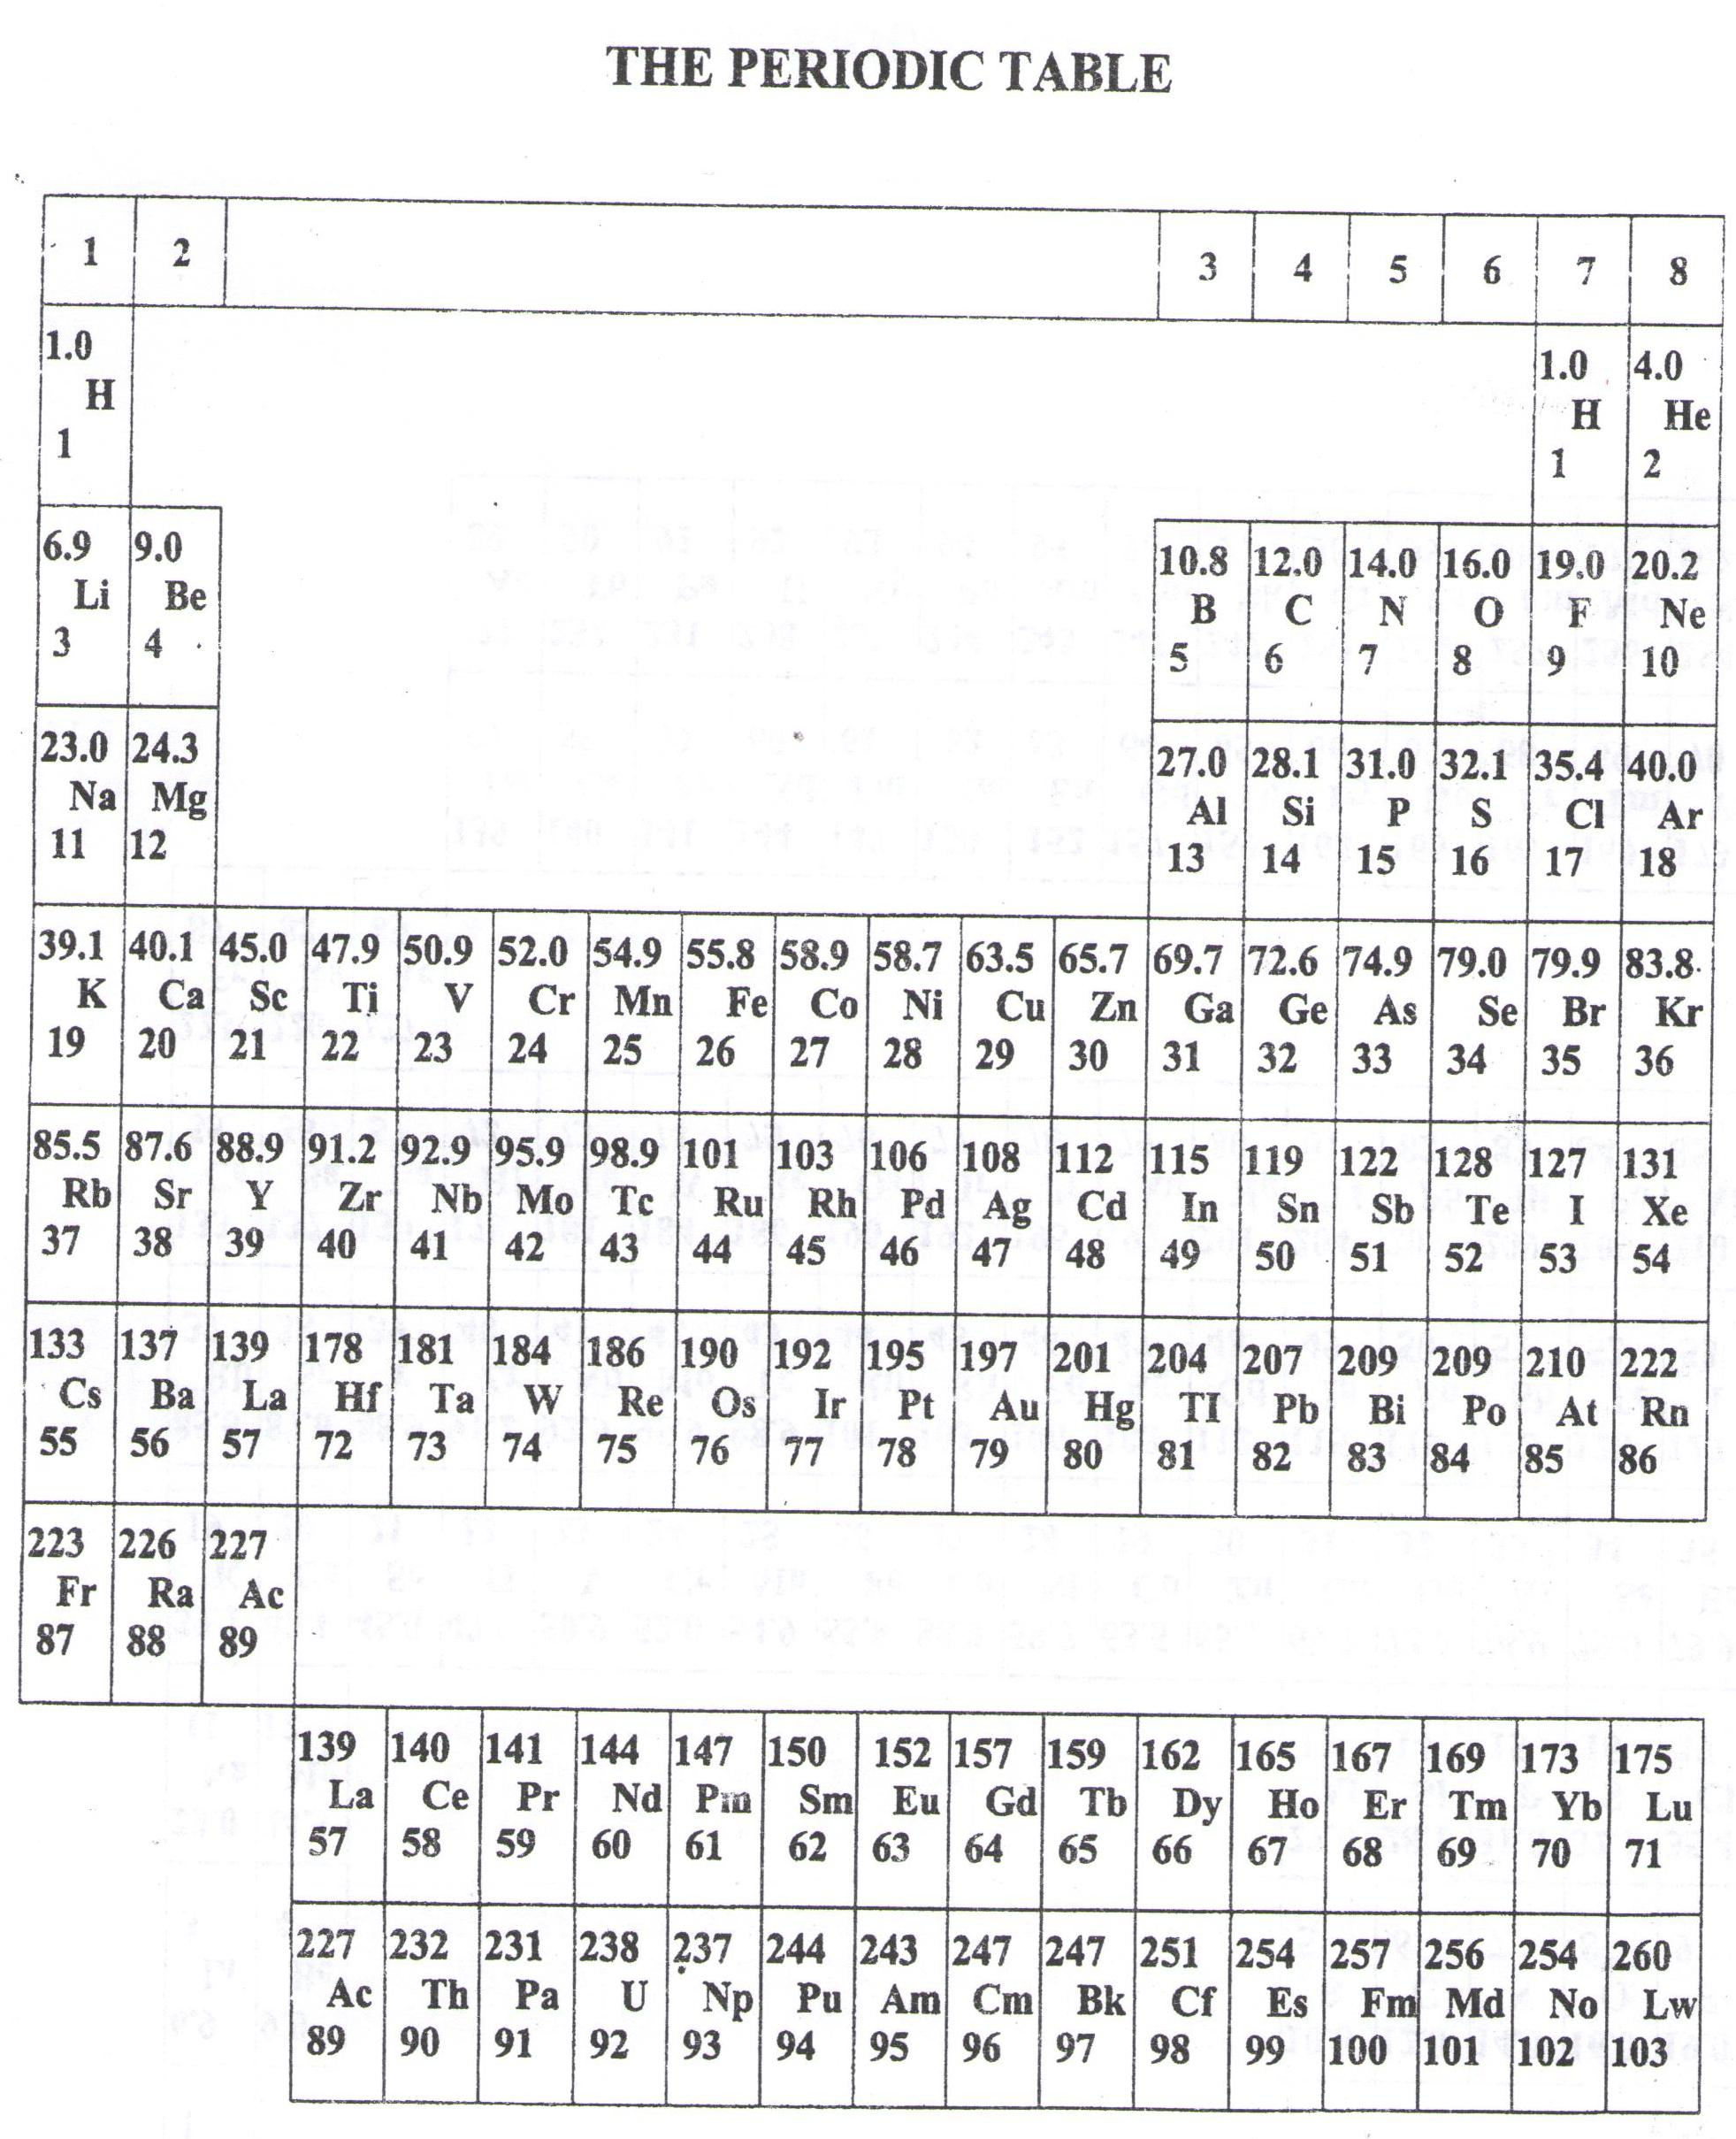

**Success = end**

WELCOME TO SENIOR SIX, YEAR 2023

This is the last page of the printed paper, Page 06